**Quiz 2 Algorithm Section B – FALL 2016**

Q 1: Find time complexity of following recurrences using Master method. Mention which case applies and show working. (5)

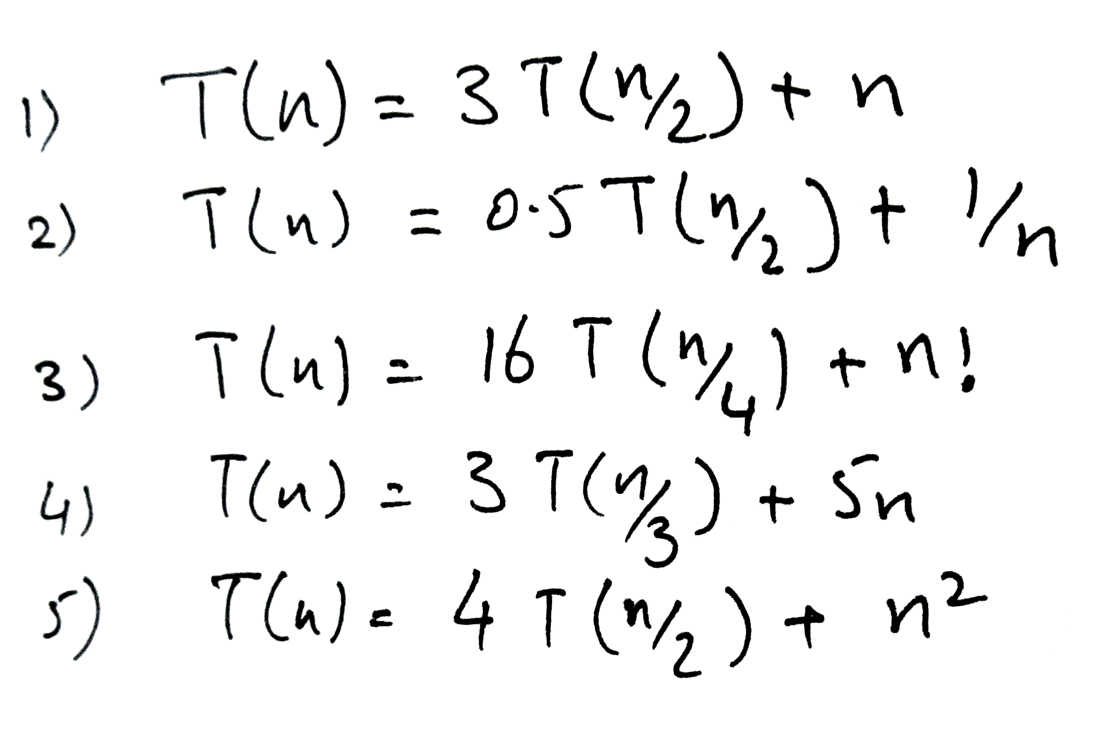

Q 2: Write upper bound, Big-Oh, O() of following time complexities. (2)

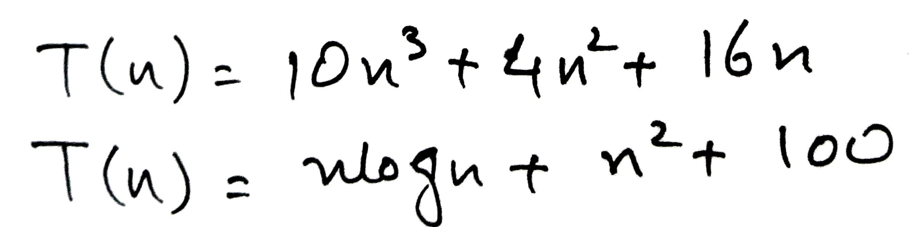

Q 3: Write an algorithm (using C/C++/Java or pseudocode as shown in class) to **find 2nd largest element in an unsorted array**. Give time complexity of your algorithm. Don’t use any built in functions. To swap 2 numbers you may use swap(i, j) method. Method should return the 2nd largest element. (5)

int Find2ndMax(Arr) {}